**University of Michigan – Dearborn**

**Department of Computer and Information Science**

**CIS 150L – Fall 2014**

Lab 5

Srinivas Simhan

10/13/14

**Table of Content**

1. Question 1 3
   1. Screenshots 3
   2. Source Code 4
2. Question 2 5
   1. Part 1 5
   2. Part 2 5
   3. Part 3 6
3. **Question 1**
   1. **Screenshots**

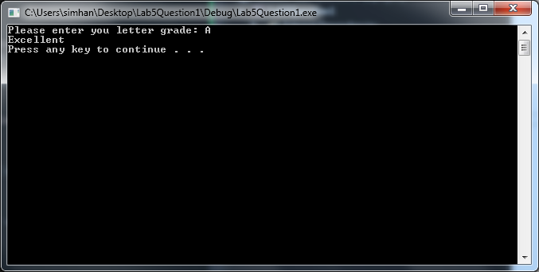

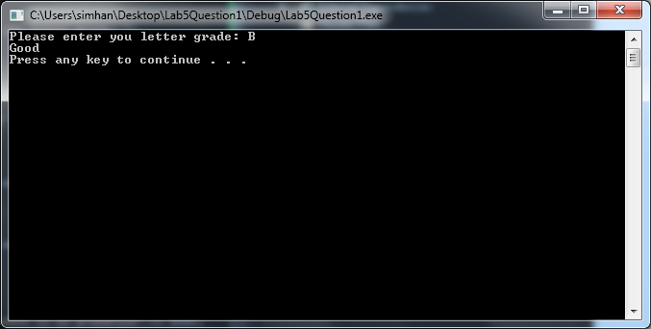

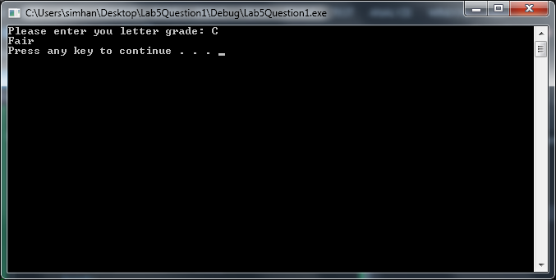

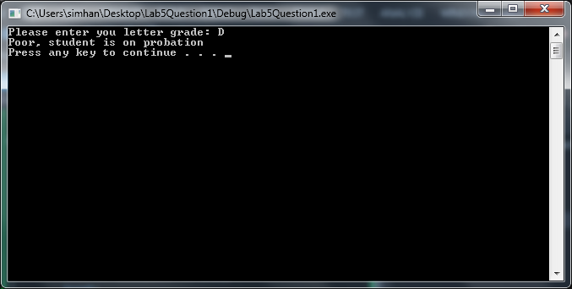

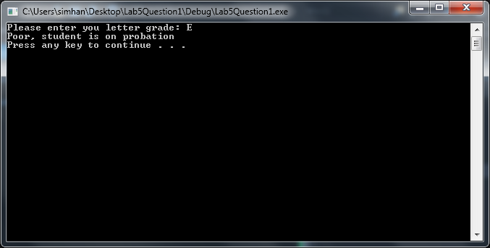

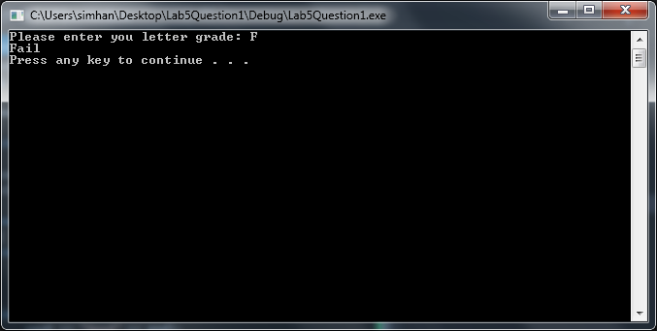

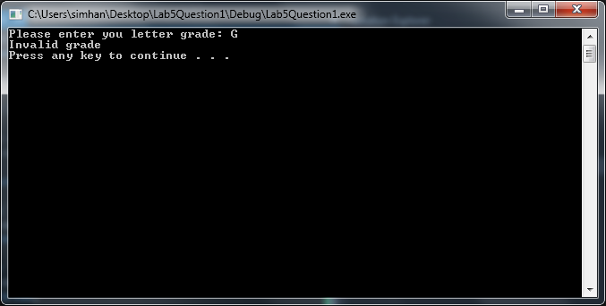

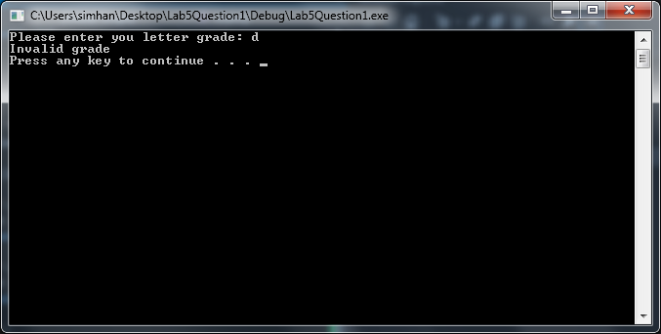

* 1. **Source Code**

//Letter Grade Display

//Author: Srinivas Simhan

//Creation Date: 10/13/2014

#include <iostream>

#include <string>

using namespace std;

int main()

{

char letterGrade;

cout << "Please enter you letter grade: ";

cin >> letterGrade;

switch (letterGrade)

{

case 'A':

cout << "Excellent" << endl;

break;

case 'B':

cout << "Good" << endl;

break;

case 'C':

cout << "Fair" << endl;

break;

case 'D':

case 'E':

cout << "Poor, student is on probation" << endl;

break;

case 'F':

cout << "Fail" << endl;

break;

default:

cout << "Invalid grade" << endl;

}

system("pause");

return 0;

}

1. **Question 2**
   1. **Part 1:**

//N Cubed

//Author: Srinivas Simhan

//Creation Date: 10/13/2014

#include <iostream>

#include <string>

#include <cmath>

using namespace std;

int main()

{

for (int n = 3;

n > 0;

n--)

cout << n << " cubed is " << pow(n, 3) << endl;

system("pause");

return 0;

}

* 1. **Part 2:**

**The program displays the input value “n”, then “cubed is”, then the value of n to the third power, and pauses at the end of the function to view the processed results. This is how it is displayed:**

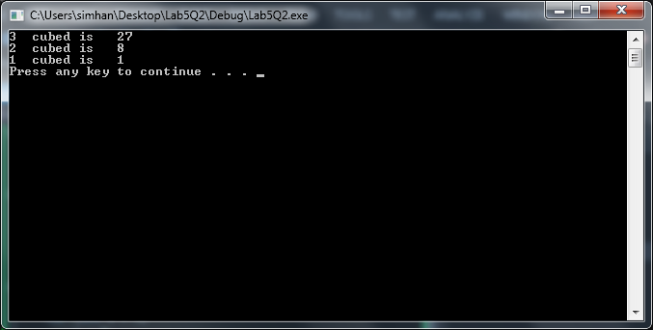

* 1. **Part 3:**

//N Cubed - Revised (while statement)

//Author: Srinivas Simhan

//Creation Date: 10/13/2014

#include <iostream>

#include <string>

#include <cmath>

using namespace std;

int main()

{

int n = 3;

while (n > 0)

{

cout << n << " cubed is " << pow(n, 3) << endl;

n--;

}

system("pause");

return 0;

}

